**Test noon.com website- Noura aleidan**

**The code:**

**package** com.experitest.auto;

**import** java.net.MalformedURLException;

**import** java.net.URL;

**import** java.util.concurrent.TimeUnit;

**import** org.openqa.selenium.By;

**import** org.openqa.selenium.Keys;

**import** org.openqa.selenium.WebDriver;

**import** org.openqa.selenium.WebElement;

**import** org.openqa.selenium.remote.CapabilityType;

**import** org.openqa.selenium.remote.DesiredCapabilities;

**import** org.openqa.selenium.remote.RemoteWebDriver;

**import** org.testng.Assert;

**import** org.testng.annotations.AfterTest;

**import** org.testng.annotations.BeforeClass;

**import** org.testng.annotations.Test;

**public** **class** noon {

WebDriver driver;

@BeforeClass

**public** **void** setUp() **throws** MalformedURLException, InterruptedException {

// Set up desired capabilities

DesiredCapabilities capabilities = **new** DesiredCapabilities();

capabilities.setCapability("BROWSER_NAME", "Android");

capabilities.setCapability("VERSION", "10.0");

capabilities.setCapability("deviceName", "Galaxy S9");

capabilities.setCapability("platformName", "Android");

capabilities.setCapability(CapabilityType.***BROWSER_NAME***, "Chrome");

// Create RemoteWebDriver instance and connect to the Appium server

driver = **new** RemoteWebDriver(**new** URL("http://127.0.0.1:4723/wd/hub"), capabilities);

driver.manage().timeouts().implicitlyWait(10, TimeUnit.***SECONDS***);

System.*setProperty*("webdriver.chrome.driver", "C:\\Users\\Sarah\\Downloads\\chromedriver.exe");

}

@Test

**public** **void** noonTest() **throws** Exception {

//Launch the website

driver.get("https://www.noon.com/saudi-en/");

//Get the search box element and send an item

WebElement search = driver.findElement(By.*id*("searchBar"));

search.sendKeys("electronics");

driver.findElement(By.*xpath*("//*[@id=\"searchBar\"]")).sendKeys(Keys.***ENTER***);

//Click on an electronic item

WebElement electronics = driver.findElement(By.*xpath*("//*[@id=\"productBox-N20675892A\"]/div/div[1]/div[1]/div/div/div/img"));

electronics.click();

WebElement cart = driver.findElement(By.*className*("cart-button"));

cart.click();

Thread.*sleep*(3000);

//Search and click a beauty item

search.sendKeys("beauty"+"\n");

WebElement beauty = driver.findElement(By.*xpath*("//*[@id=\"productBox-N43772904A\"]/div/div[1]/div[1]/div/div/div/img"));

beauty.click();

WebElement cart2 = driver.findElement(By.*className*("cart-button"));

cart2.click();

Thread.*sleep*(3000);

//Search and click a groceries item

search.sendKeys("groceries"+"\n");

WebElement groceries = driver.findElement(By.*xpath*("//*[@id=\"productBox-N43362854A\"]/div/div[1]/div[1]/div/div/div/img"));

groceries.click();

WebElement cart3 = driver.findElement(By.*className*("cart-button"));

cart3.click();

Thread.*sleep*(3000);

//Search and click a groceries item

search.sendKeys("home"+"\n");

WebElement home = driver.findElement(By.*xpath*("//*[@id=\"productBox-N32048618A\"]/div/div[1]/div[1]/div/div/div/img"));

home.click();

WebElement cart4 = driver.findElement(By.*className*("cart-button"));

cart4.click();

Thread.*sleep*(9000);

//Search and click a school item

search.sendKeys("school"+"\n");

WebElement schoolgoods = driver.findElement(By.*xpath*("//*[@id=\"productBox-N20609833A\"]/div/div[1]/div[1]/div/div/div/img"));

schoolgoods.click();

WebElement cart5 = driver.findElement(By.*className*("cart-button"));

cart5.click();

Thread.*sleep*(3000);

//Click on checkout button

WebElement checkout = driver.findElement(By.*xpath*("//*[@id=\"__next\"]/div/section/div[2]/div/div[1]/div[2]/button[1]"));

checkout.click();

Thread.*sleep*(3000);

//Click on buy button

WebElement buy = driver.findElement(By.*className*("ripple"));

buy.click();

Thread.*sleep*(3000);

//Enter email address

WebElement email = driver.findElement(By.*name*("email"));

email.sendKeys("noura44aleidan@gmail.com");

Thread.*sleep*(3000);

//Enter the passowrd

WebElement pass = driver.findElement(By.*name*("password"));

pass.sendKeys("*****");

Thread.*sleep*(3000);

//Click on signin button

WebElement signin = driver.findElement(By.*id*("submitLoginFormBtn"));

signin.click();

Thread.*sleep*(3000);

//Click on Continue button

WebElement con = driver.findElement(By.*xpath*("//button[@aria-label='Continue']"));

con.click();

Thread.*sleep*(3000);

//Click on add new card button

WebElement addcard = driver.findElement(By.*xpath*("//button[@aria-label='Add a New Card']"));

addcard.click();

Thread.*sleep*(3000);

//Enter wrong card number

WebElement card = driver.findElement(By.*id*("ccNumber"));

card.sendKeys("12345667");

Thread.*sleep*(3000);

// expected error text

String exp = "Invalid card number";

// identify actual error message

WebElement m = driver.findElement(By.*className*("textError"));

String act = m.getText();

System.***out***.println("Error message is: " + act);

// verify error message with Assertion

Assert.*assertEquals*(exp, act);

}

@AfterTest

**public** **void** End() {

driver.quit();

}

}

**The output:**

[**https://www.dropbox.com/s/kholoa4ufoe2bkw/noon.com%20test.mp4?dl=0**](https://www.dropbox.com/s/kholoa4ufoe2bkw/noon.com%20test.mp4?dl=0)

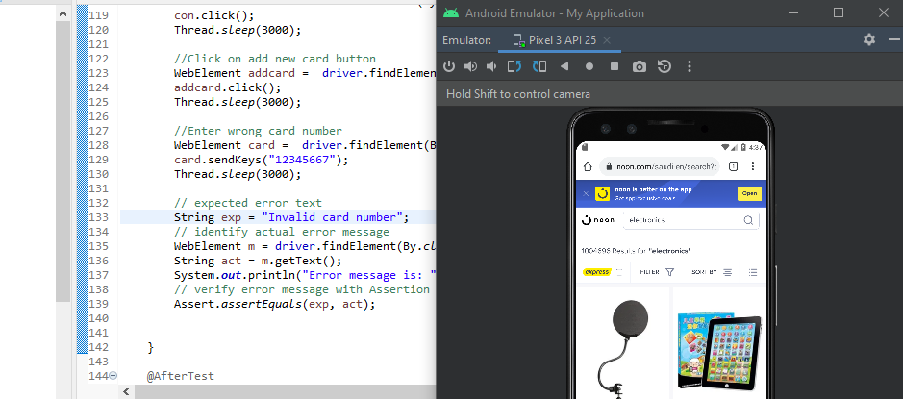

**Test Cases:**

|  |  |  |  |  |  |
| --- | --- | --- | --- | --- | --- |
| TC ID | Test case | Test steps | Expected result | Actual result | Pass / Fail |
| TC1 | Verify if the website is opened. | 1. Open the url: https://www.noon.com/saudi-en/. | The website should be opened. | The website is opened. | Pass |
| TC2 | Verify if the user can write in the Search field. | 1. Write in the Search field. 2. Click on the Search button. | The website should open the page specified with the Search field. | The website opened the page specified with the Search field. | Pass |
| TC3 | Verify if the links on the website are clickable. | 1. Click on any link on the website. | The website should open the page specified with the clicked link. | The website opened the page specified with the clicked link. | Pass |
| TC4 | Verify if the user can add items to the cart. | 1. Choose an item from the website. 2. Click on the “Add to Cart” button. | The item should be added to the cart. | The item has been added to the cart. | Pass |
| TC5 | Verify if the user can click on “Checkout” button. | 1. Choose an item from the website. 2. Click on the “Add to Cart” button. 3. Click on “Checkout” button. | The user should be able to click on “Checkout” button. | The user can click on “Checkout” button. | Pass |
| TC6 | Verify if the user can click on “Buy” button. | 1. Choose an item from the website. 2. Click on the “Add to Cart” button. 3. Click on “Checkout” button. 4. Click on “Buy” button. | The user should be able to click on “Buy” button. | The user can click on “Buy” button. | Pass |
| TC7 | Verify if the user can sign in. | 1. Choose an item from the website. 2. Click on the “Add to Cart” button. 3. Click on “Checkout” button. 4. Click on “Buy” button. | The sign in page should be opened. | The sign in page is opened. | Pass |
| TC8 | Verify if the user can write in the “Email” field. | 1. Choose an item from the website. 2. Click on the “Add to Cart” button. 3. Click on “Checkout” button. 4. Click on “Buy” button. 5. Enter the email. | The user should be able to write in the “Email” field | The user can write in the “Email” field. | Pass |
| TC9 | Verify if the user can write in the “Password” field. | 1. Choose an item from the website. 2. Click on the “Add to Cart” button. 3. Click on “Checkout” button. 4. Click on “Buy” button. 5. Enter the password. | The user should be able to write in the “Password” field | The user can write in the “Password” field. | Pass |
| TC10 | Verify if the user can click on “Sign In” button. | 1. Choose an item from the website. 2. Click on the “Add to Cart” button. 3. Click on “Checkout” button. 4. Click on “Buy” button. 5. Enter the email and password. 6. Click on the “Sign In” button. | The user should be able to click on “Sign In” button. | The user can click on “Sign In” button. | Pass |
| TC11 | Verify if the user can click on “Continue” button. | 1. Choose an item from the website. 2. Click on the “Add to Cart” button. 3. Click on “Checkout” button. 4. Click on “Buy” button. 5. Enter the email and password. 6. Click on the “Sign In” button. 7. Click on “Continue” button. | The user should be able to click on “Continue” button. | The user can click on “Continue” button. | Pass |
| TC12 | Verify if the user can click on “Pay with Card” button. | 1. Choose an item from the website. 2. Click on the “Add to Cart” button. 3. Click on “Checkout” button. 4. Click on “Buy” button. 5. Enter the email and password. 6. Click on the “Sign In” button. 7. Click on “Continue” button. 8. Click on “Pay with Card” button. | The user should be able to click on “Pay with Card” button. | The user can click on “Pay with Card” button. | Pass |
| TC13 | Verify if the user can write in the “Card Number” field. | 1. Choose an item from the website. 2. Click on the “Add to Cart” button. 3. Click on “Checkout” button. 4. Click on “Buy” button. 5. Enter the email and password. 6. Click on the “Sign In” button. 7. Click on “Continue” button. 8. Click on “Pay with Card” button. 9. Write in the “Card Number” field. | The user should be able to write in the “Card Number” field | The user can write in the “Card Number” field. | Pass |
| TC14 | Verify if the error message will appear after entering invalid card number. | 1. Choose an item from the website. 2. Click on the “Add to Cart” button. 3. Click on “Checkout” button. 4. Click on “Buy” button. 5. Enter the email and password. 6. Click on the “Sign In” button. 7. Click on “Continue” button. 8. Click on “Pay with Card” button. 9. Write in the “Card Number” field. | The error message “Invalid Card Number” should appear. | The error message “Invalid Card Number” has appeared. | Pass |